Prague University of Economics and Business and Charles University

Are inviting you to the

24th International Conference on

Environmental Economics, Policy and
International Environmental Relations

24-25 November 2022

Room 244 NB and 255 NB

Prague University of Economics and Business
Main Campus, W. Churchill Sq. 4, Prague 3 – Žižkov

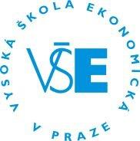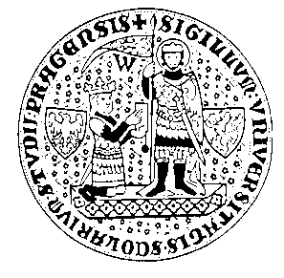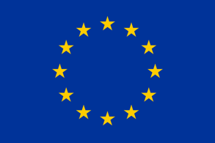

Final program

Day 1 Room 244 NB

9:10-9:20 Registration
9:20-9:30 Opening

Session I Chair: Karel Janda

9:30-10:45 Perception of economic instruments in the
forestbased sector of the EU
Diana Carolina Huertas Bernal, Andreas Nikodemus, Hájek Miroslav

Cooperation of local stakeholders as an effective tool for implementation of collaborative management practices into environmental management policies in protected areas
Bronislav Farkač, Kateřina Mácová, Eva Sochová, Martina Kobyláková, Klára Čámská

How will the Czech Republic deal with the new European legislation on disposing PET bottles?
Jakub Král

10:45-11:00 Tea break

Session II Chair: Salim Turdaliev

11:00-12:15 Household specific social norms and the propensity to purchase dirty fuels: empirical evidence from a natural experiment
Salim Turdaliev, Karel Janda

Social cues and electricity consumption: evidence from a randomized control trial in Armenia
Yermone Sargsyan, Salim Turdaliev, Silvester van Koten

The effect of temperature and humidity on solar energy generation in Cyprus
Akram Elahi Gol

12:15-13:00 Lunch time refreshment

13:00-13:35 Keynote lecture 1
Science/research and their impact on environmental policy decision-making: Chemicals and waste management case
Kateřina Šebková, Director of the National Centre for Toxic Compounds and of the Stockholm Convention Regional Centre, Brno
Chair: Jiří Hlaváček

13:40-14:15 Keynote lecture 2
Experimental economics: Principles of methodology and typical applications in energy economics
Silvester van Koten, Senior Researcher and docent at FSE-UJEP Ústí nad Labem, and Research Associate at CERGE-EI, Prague
Chair: Jean-François Auger

14:20-14:55 Keynote lecture 3
Environmental social governance (ESG) issues and career prospects of corporate executives
Gonul Colak, Profesor of Finance at Sussex and Hanken Universities
Chair: Karel Janda

14:55-15:00 Publishing options in journals - info

14:55-15:15 Tea break

Session III Chair: Gonul Colak

15:15-16:30 Can geopolitical risks significantly affect green finance: evidence from top green bond issuer countries
Karel Janda and Binyi Zhang

Renewable procurement auctions and default: pre-qualification requirements
Silvester van Koten, Bert Willems

Local and regional economic effects of water outdoor recreation around Vltava river dam cascade
Kateřina Mácová

16:30-16:45 Tea break

Session IV Chair: Yermone Sargsyan

16:45-18:00 Implementing local climate change adaptation actions: The role of various policy instruments in mopane (Colophospermum mopane) woodlands,
northern Namibia
Andreas Nikodemus and Miroslav Hájek

The influence of knowledge and innovations on sustainable national development
Oleksandr Kubatko, Vladyslav Piven, Pavlo Denysenko

Analysis of the attitudes of consumers of tourism services towards waste and their consequences for the sustainable development of tourism in the
Slovak Republic
Ľubomíra Kubíková, Miroslava Barkóciová, Stanislav Rudý

Analysis of intentions towards ecological behavior in air trasportation
Martin Vaško, Zuzana Kvítková, Denisa Růžičková

18:00 End of Day 1
Day 2 Room 255 NB

Egg-timer session
Chair: Ľubomíra Kubíková

10:00-12:00 Comparison of agricultural biomass energy flows in Czechia and Poland before and after the collapse of communism
Petra Grešlová

Attitudes of Czech anglers toward changes of fees for trout fishing
Tomáš Zapletal, Jan Grmela

Sustainability and security nexus: The case of Czech Republic
Ondřej Kolínský

Enhancing synergies between higher education and research for climate change and smart cities: A practical perspective within a Czech-Norwegian cooperation
Ticiano Costa Jordao

Trends and analysis of European Union heis on teaching sustainability tourism in bachelor and master programs
Wilson Jordao Filho

12:00-13:00 Lunch time refreshment

13:00-14:00 Book of extended abstracts – Workshop with the editor (room 255 NB and TEAMS)

14:00 End of Conference

Registration (for both on-line and personal participation):
https://environmental-conference.vse.cz/

Format of the conference
At the conference, presentations will be made in standard sessions (15-20 minutes presentation, 10 minutes discussion) and egg-timer sessions (7 minutes presentation, 3 minutes discussion). If an accepted paper cannot be presented in person, the author can present it virtually in Microsoft Teams.
The conference will publish a book of abstracts and extended abstracts.
Peer-reviewed journals World Economy and Policy and Mechanism of Economic Regulation, which sponsors the conference, will welcome the submission of papers.
The conference is free of charge. Participants have to make their own travel and accommodation arrangements.

Scientific Committee
Prof. Petr Šauer, Prague University of Economics and Business
Dr. Milan Ščasný, Charles University
Dr. Jean-François Auger, Charles University and Prague University of Economics and Business
Assoc. Prof. Miroslav Hájek, Czech University of Life Science Prague
Prof. Karel Janda, Charles University and Prague University of Economics and Business
Prof. Leonid Melnyk, Sumy State University
Dr. Zbyněk Dubský, Prague University of Economics and Business
Dr. Jiří Hlaváček, Prague University of Economics and Business
Prof. Oleksandr V. Kubatko, Sumy State University

Further Information
Scientific issues: Prof. Petr Šauer, e-mail: sauer@vse.cz
Organization: Ms. Kateřina Kafková, e-mail: kafkova.isb@email.cz

Conference venue
The conference will be held at the University of Economics, Winston Churchill Square 4, Prague 3. Campus Žižkov, New Building (NB), room 244 NB. (GPS: 50.0842150N, 14.4411958E).

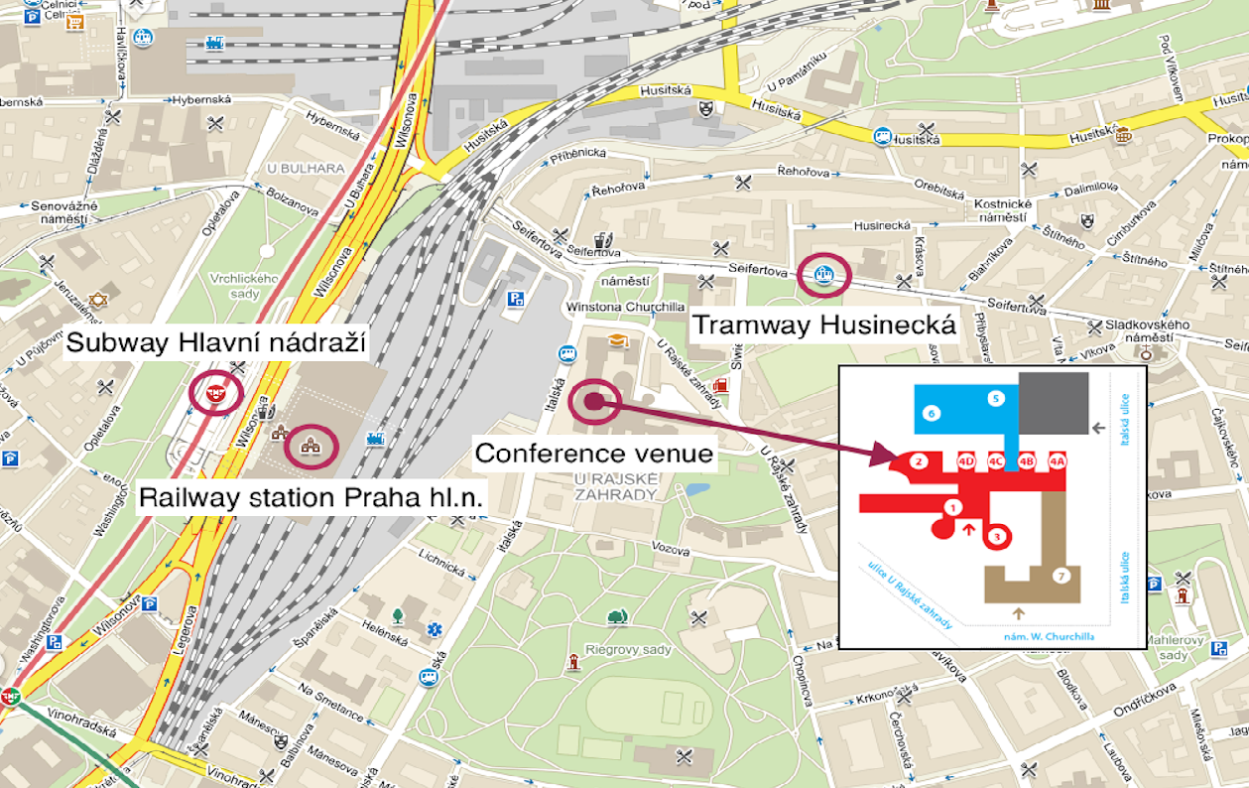

Acknowledgements
The conference is financially supported by the grant IGS Faculty of International Relations, University of Economics and Business Prague, No. 21/2022. This conference is part of a project that has received funding from the European Union’s Horizon 2020 research and innovation programme under the Marie Skłodowska-Curie grant agreement No 870245.

